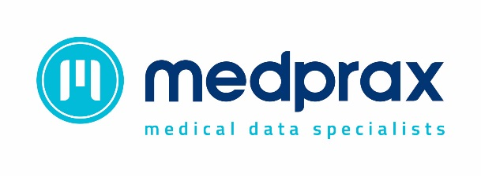
2017 Medical Aid Changes

- Bankmed
The PMB option has been renamed to the Essential Option.

- Bestmed
Pulse 1
Bestmed will do their own administration of the Pulse 1 option, this option is no longer administered by CareCross
Pulse 2
Bestmed will also administer Pulse 2, this option is no longer part of ONECARE.

- Bonitas
LMS and Bonitas amalgamate.
A new option BonComplete has been introduced and the Hospital Plus and Hospital Standard options from LMS are now under Bonitas.

- Camaf
Camaf is introducing the Family Practitioner Network and members on the Network Choice option will be required to use this network to obtain full coverage.

- Commed
Acute and Chronic claims for the Roots option must be submitted to Carecross.

- Compcare Wellness
A new savings option Unisave is being introduced.
The Mumed ED Network option is to be discontinued

- Discovery Medical Aid

Smart Plan – The Original Smart Plan is renamed Classic Smart and a new option Essential Smart is introduced.

- Fedhealth Medical Scheme
The Ultima 200B option is renamed to Maxima Advanced
3 new options are introduced, Maxima Basis Grid, Maxima Saver Grid and Maxima Core Grid.

- Gems
Emerald Value Option (EVO) introduced for 2017

- Momentum Health
Members on Momentum Ingwe and Health4me can also consult with practitioners on the Momentum CareCross General Practitioner Network.

- Nammed
The Access option becomes the Basic option.

- Netcare
Discovery health will now be the administrator of Netcare Medical Scheme

- Pan African Managed Care
New Wesmart Scheme added under Pan African.

- Pick n Pay
Pick n Pay introduces a new Primary Option and the network provider is Carecross.

- Platinum Health Medical Scheme
The Platsave option has been discontinued and for the PlatCap option members can utilise Platinum health DSP’s and the CareCross Network.

- Resolution Health
Two new options are being introduced : Millenium Select and the Progressive Flex Plus Option. The Classic option is to be discontinued.

- Samwumed
Medicine claims for this scheme are administered by Medscheme

- Selfmed
Selfnet Essential a new Carecross option has been introduced.
- Sizwe
The Hospital Care plan for major medical expenses only has been introduced.

- Topmed
The following options will be changing their names:
Rainbow Comprehensive to Comprehensive
Professional to Executive
Paladin Comprehensive to Family
Hospital to Essential.

- Witbank Coalfields
In Hospital Claims for the Comprehensive and the new Midmas option will be processed by Universal Healthcare.
Ntsika a new low cost network option will be administered by Universal.

.

